Bart Bryant-Mole
Durham University

Lautner, John Edward (1911-1994)

Introductory paragraph:

While the American architect John Lautner may not have considered himself a Modernist, he nevertheless made a significant contribution to the branch of Modernist architecture that emerged in Southern California during the mid-20th century, pioneered by architects such as RUDOLPH SCHINDLER , RICHARD NEUTRA and FRANK LLOYD WRIGHT. Though he was wary of being seen as an imitator of Wright, under whom he had worked as an apprentice for six years, Lautner’s work does reflect several of his mentor’s architectural principles, such as flowing space, harmony with nature and site-specific designs. Lautner’s visually arresting buildings, however, took these ideas further than ever before. His ambitious projects, as well as being architecturally innovative, were feats of modern engineering. These daring structures stood in stark contrast to the minimal, machine-influenced INTERNATIONAL STYLE buildings which had dominated Modernist architecture since the 1930s. Lautner’s residential projects, in particular, gained widespread attention through the photography of Julius Shulman, their appearance in Hollywood films and their endorsement by the rich and famous of Los Angeles. While contemporaneous critics were divided in their opinions of Lautner’s work, he later achieved international acknowledgement and respect, and is now considered an important figure within the Mid-Century Modern design movement.

Main text:

In 1933, the American architect John Lautner was accepted onto Frank Lloyd Wright’s innovative Taliesin Fellowship programme. He worked under Wright for the next six years, taking an active part in the build of Taliesin West (1937) and supervising several other projects, before leaving to set up his own practice in Los Angeles.

Lautner made a conscious decision to develop his own distinctive architectural style, taking his mentor’s principle of flowing space to new extremes by blurring the boundary between the interior and the exterior of the building. Façades are dissolved by sheet glass walls, with broken canopies and skylights creating an intermediary space that connects the inside with the outside. Like Wright, Lautner took his inspiration from nature, giving rise to free, organic forms. Lautner’s designs work with the surrounding landscape, on occasions bringing it physically into the building. Such is the case with the Elrod House (1968), where exposed stone from the foundations of the site forms an internal wall. This unity of nature and architecture is a theme that permeated Lautner’s work throughout his career.

Lautner’s radical designs were visually arresting, with many of his buildings, such as the Sheats Goldstein Residence (1963), appearing to defy gravity with vast, unsupported canopies¹. Lautner embraced new building technologies and materials in order to realise his ambitious projects. One example of this is the Reiner Residence, or ‘Silvertop’ (1963-67), where Lautner made use of post-tensioned concrete to create the sweeping, unbroken planes of the roof and the cantilevered driveway.

Lautner’s preliminary research of each site and the surrounding topography led to unique and site-specific designs. One such example is the Malin Residence, also known as ‘Chemosphere’ (1960), where the challenge of a steeply-sloping site in an earthquake zone was met with the imaginative solution of sitting the house atop a twenty-nine foot high concrete column².

Lautner received both residential and commercial commissions; the latter consisting primarily of roadside buildings. Examples include Henry’s drive-ins (1947, 1957) and the coffee shop Googie’s (1949), from which GOOGIE ARCHITECTURE takes its name. These buildings are characterised by eye-catching, angular forms, the use of multiple, contrasting materials and a lack of formality. They did not meet with universal critical acclaim however, criticised by some as being undisciplined or kitsch.

Lautner found greater success with commissions for private homes. His houses, with their open-plan interiors, panoramic city views and luxurious swimming pools, epitomised the opulence of Southern Californian living. Several of his works made their way into Hollywood films; the Elrod House, for example, features in the 1971 James Bond film Diamonds Are Forever³.

Overall, Lautner produced nearly two hundred designs, of which over one hundred were constructed. Although he never received any large-scale public commissions and his commercial designs were often subject to negative reviews, Lautner’s private homes occupy a significant place in the Mid-Century Modern design movement.

List of works

1949 Googie’s Coffee Shop, Los Angeles, California, USA
1960 Malin Residence (‘Chemosphere’), Los Angeles, California, USA
1962 Garcia Residence, Los Angeles, California, USA
1963 Sheats Goldstein Residence, Beverly Hills, California, USA
1963 Reiner Residence (‘Silvertop’), Los Angeles, California, USA
1968 Elrod House, Palm Springs, California, USA
1973 Arango Residence (‘Casa Marbrisa’), Acapulco, Mexico

References

¹ Treats! Magazine interview with Goldstein
http://treatsmagazine.com/video/goldsteinland/

² L.A. Times ‘Chemosphere’ photo gallery
http://www.latimes.com/features/home/la-hm-john-lautner-chemosphere-photos,0,1972395.photogallery

³ John Lautner Foundation – Movies featuring Lautner buildings
http://www.johnlautner.org/wp/?p=32

Further reading

Bryant-Mole, B (2013) Googie Architecture: A Reflection of Post-War America, Durham: Durham University. Unpublished dissertation.

Campbell-Lange, B.A. (1999) John Lautner, New York: Taschen

Cohen, J.L., Escher, F. & Olsberg, N. (2008) Between Earth and Heaven: The Architecture of John Lautner, New York: Rizzoli

Hess, A. & Weintraub, A. (1999) The Architecture of John Lautner, New York: Rizzoli

L.A. Times – ‘The architecture of John Lautner’ photo gallery http://www.latimes.com/features/la-hm-lautner0410-pg,0,7076729.photogallery

Lecture given by John Lautner at Southern California Institute of Architecture (23 January, 1991)
http://sma.sciarc.edu/video/john-lautner/.

Visual material

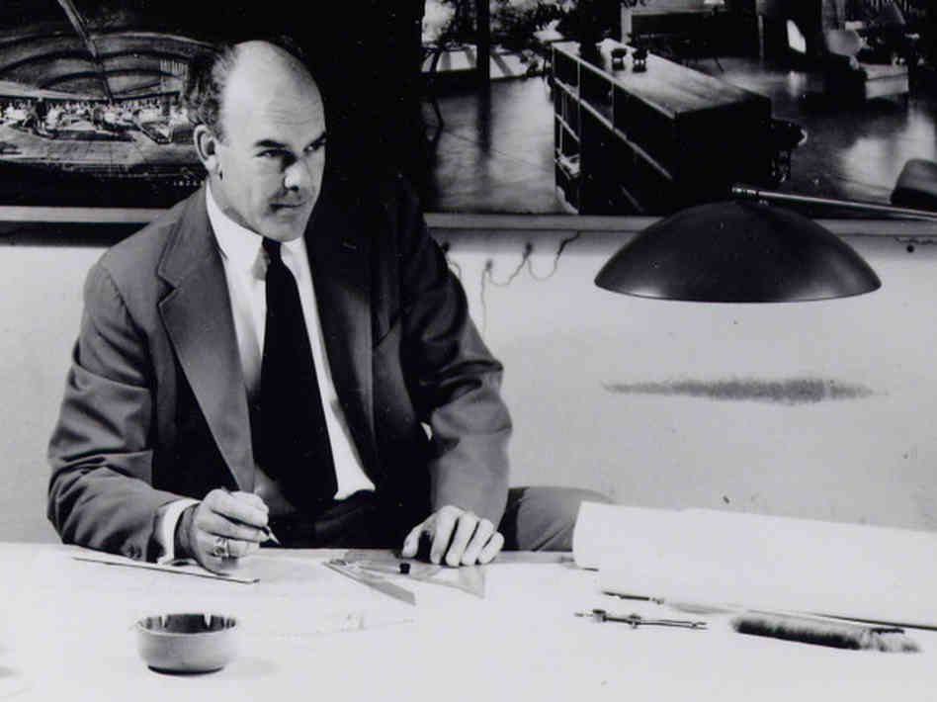
John Lautner, photographer unknown
Copyright: John Lautner Foundation
http://media.npr.org/assets/img/2011/12/02/lautner-3-photographer-unknown-9803203c2f5e3a2b4f0fe2ebcca94145d16a9ff0-s6-c10.jpg

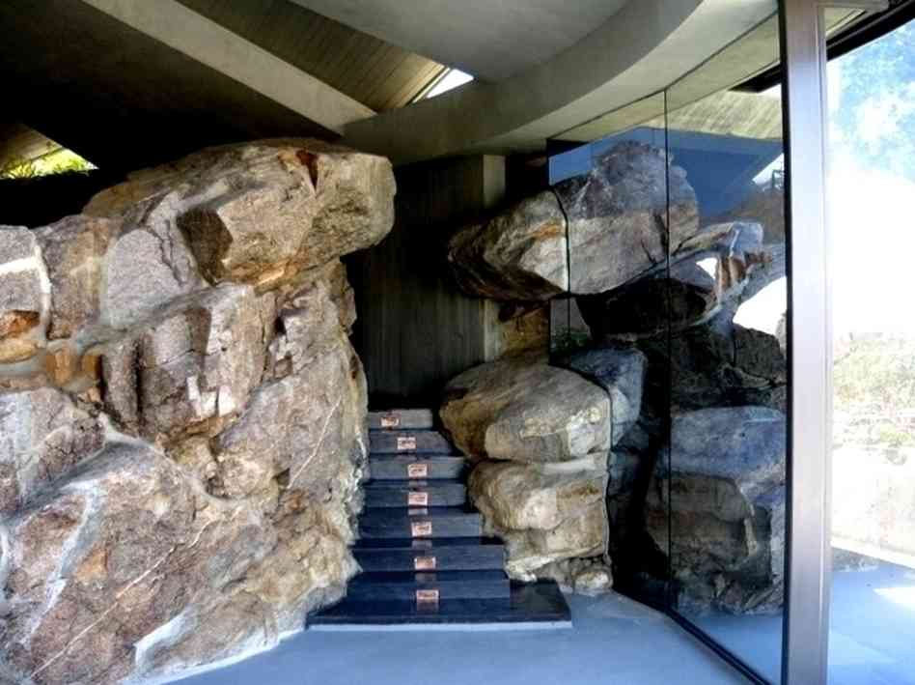
Interior of Elrod House, photo by Murray Grigor
Copyright: John Lautner Foundation
http://media.npr.org/assets/img/2011/12/02/elrod_murray-grigor_01-7f17f1a6d667f5965ca7800424721c5940c603b2-s6-c10.jpg

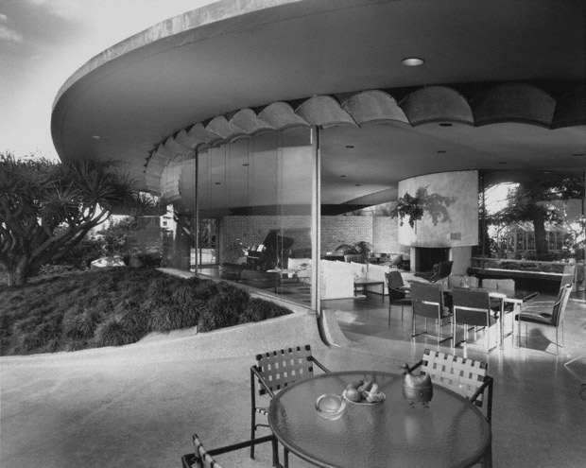
Silvertop, photo by Julius Shulman
Copyright: Getty Research Institute
http://blogs.getty.edu/iris/happy-100th-birthday-john-lautner/

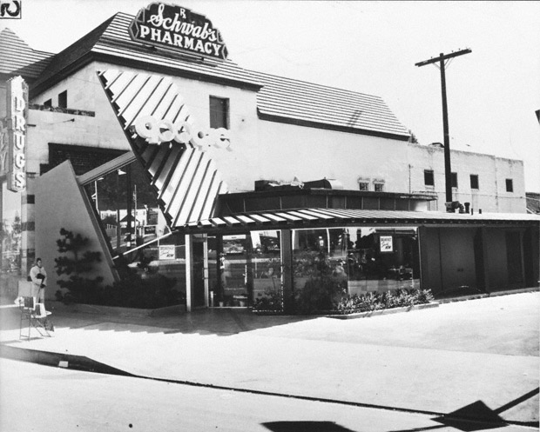
Googie’s Coffee Shop, photo by Julius Shulman
Copyright: Getty Research Institute
http://blogs.getty.edu/iris/happy-100th-birthday-john-lautner/

